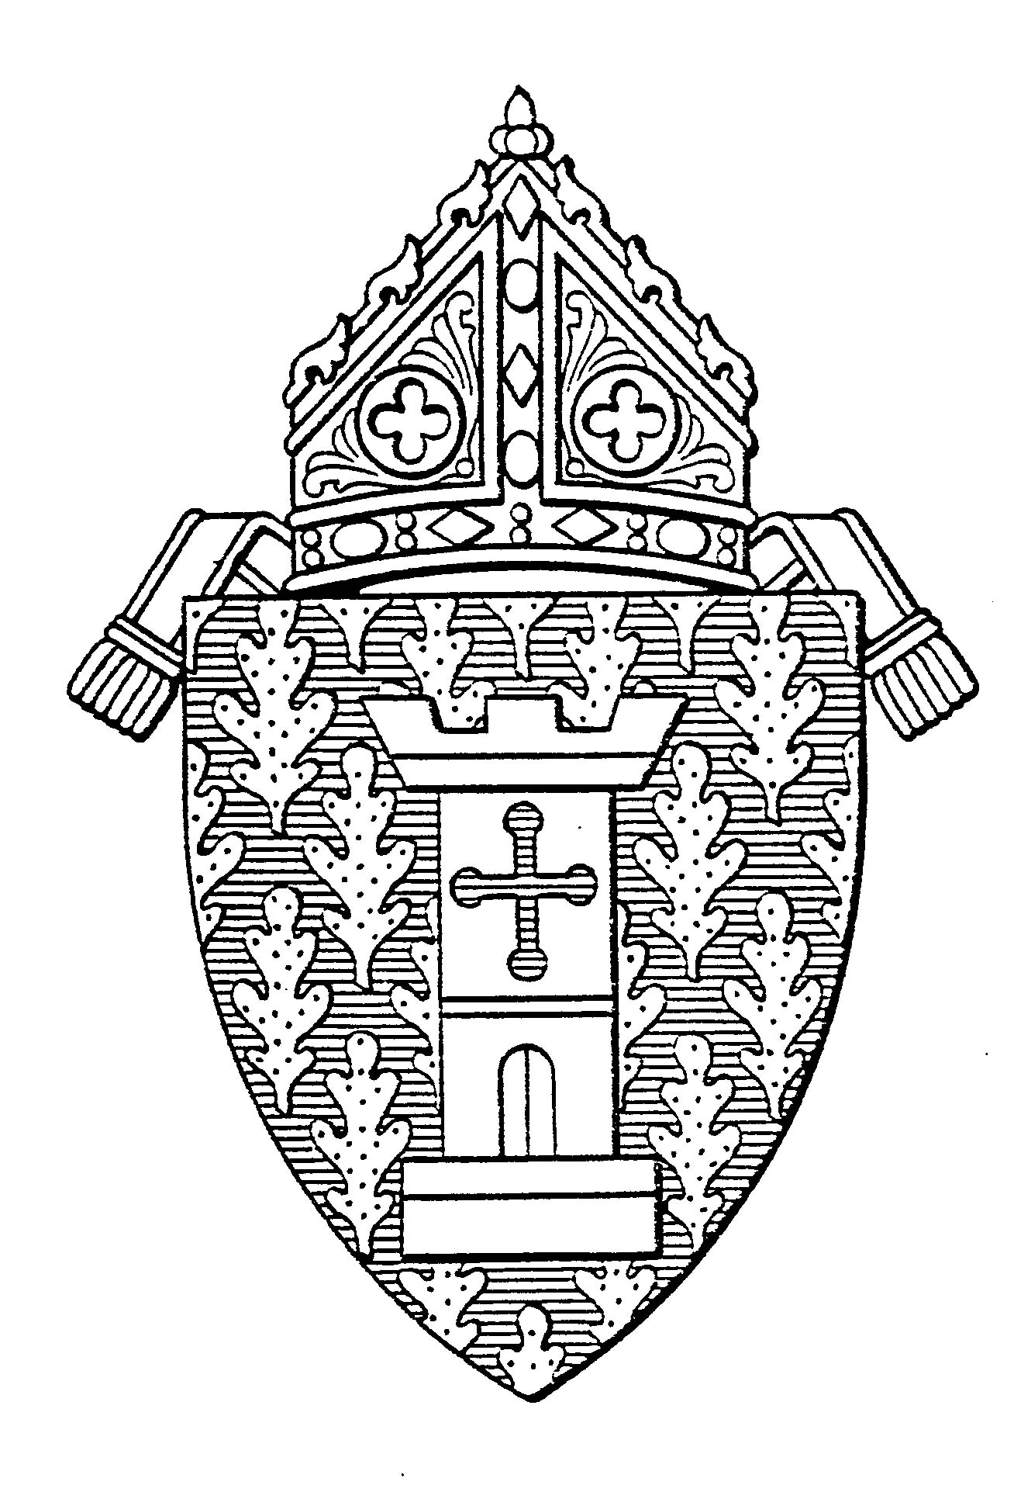
Diocese of Ogdensburg
Diocesan Vocation Office

100 Elizabeth Street
P.O. Box 369

Ogdensburg, NY 13669
Telephone: 315-393-2920 Fax: 866-393-7642 E-Mail: crussell@rcdony.org

Letters of Recommendation

One must be from your pastor.

Obtain three other letters from people who know you well. They may not be relatives.

Suggestions: employer, former pastor, teacher

Give each person a copy of the guidelines below to assist each writer with writing the recommendation.

Guidelines for Letters of Recommendation

Please send the letter directly to:
Ms. Cathy Russell
Vocation Coordinator
P.O. Box 369
Ogdensburg, NY 13669

The letter of recommendation should address the following:

- How long have you known the applicant?
- How well have you known him?
- What do you consider to be the applicant’s assets, skills, talents, interests, personal qualities?
- What do you consider to be the applicant’s significant limitations, physical, mental social, emotional?
- How would you assess the applicant’s character and level of maturity?
- How would you assess the applicant’s level of spiritual growth and development?
- What kind of experiences in Church ministry has he had?
- How would you evaluate his capacity and preparedness to embrace a life of celibacy?
- Why are you recommending him for a Priestly Formation Program for the Diocese of Ogdensburg?

