**SCHOOL PROFIT & LOSS BUDGET OVERVIEW 2025-2026**

***QuickBooks Pro* Instructions**

Before you begin to create a School Budget Report using QuickBooks Pro software we will need to have the following two steps completed:

1. Have a budget inputted into QuickBooks Pro for the fiscal year that the report is due. If not, please review the set-up instructions *“How to Create a School Budget in QuickBooks Pro”*.
2. You should make sure your school chart of accounts has all the required accounts from the diocesan chart of accounts. They must be in the proper header accounts and account groupings.

To create a School Budget Report in QuickBooks, follow these steps:

**Step 1:** From the main menu select Reports, then select Budgets from the drop-down menu and select Budget Overview, shown in Figure 1.

Figure 1: Main menu and Reports drop-down menu.

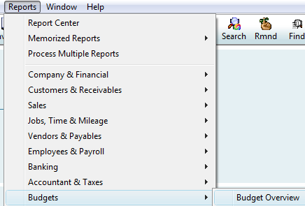

**Step 2:** From the Budget Report window select the budget that will be used in the budget report. In figure 2 the example selected is the budget from 2025-26 Profit & Loss by Account and Class if you have a Pre-K, if not, then select 2025-26 Profit & Loss by Account. Select the Next button to continue.

Figure 2: Budget Report window.

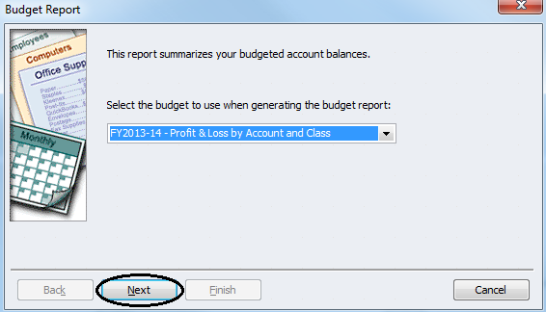

FY2025-26 – Profit & Loss by Account and Class

**Step 3:** The Budget Report window will display the layout option of Account by Month, but if you have a Pre-K, then select the drop-down box and select Account by Class. Select the Next button. After selecting the Next button in Figure 3 you will be prompted to select the Finish button (window not shown) to create the report.

Figure 3: Budget Report window.

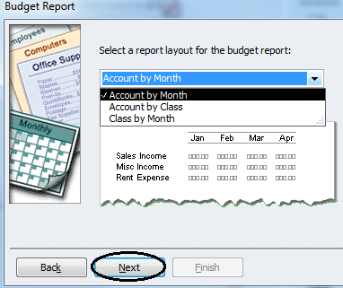

**Step 4:** QuickBooks now displays the Profit & Loss Budget Overview, which you will customize by selecting the Customize Report button, shown in figure 4. Figure 5 is an example of a Pre-K school by class Profit & Loss Budget Overview.

Observe: In figure 4 this particular budget report by month account number 401.10 “Supporting Parent Payments” has no figures for the months of July and August, since the budgeted amounts started in the month of September. QuickBooks added scroll bars, both vertical and horizontal, so you can scroll through the window of this report. For example, you can use the vertical scroll bar to move to the right in order to view the month of September.

Figure 4: Profit & Loss Budget Overview.

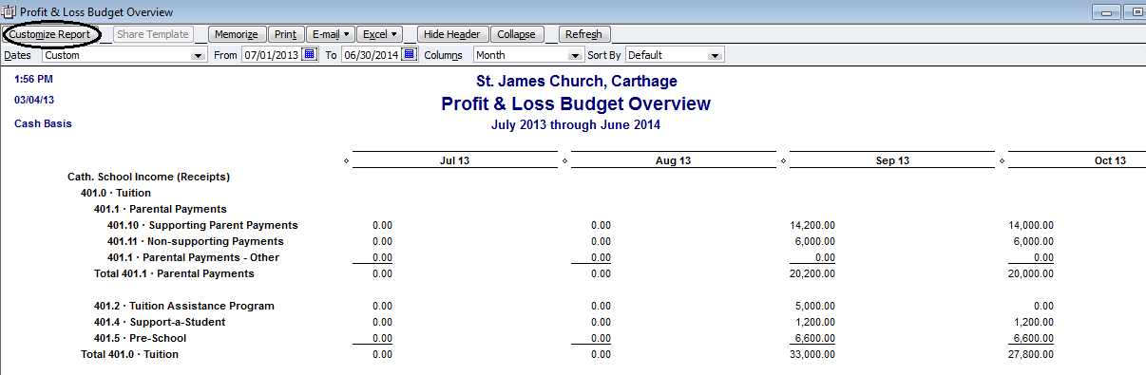

Aug 25

Jul 25

06/30/2026

07/1/2025

Oct 25

Sep 25

July 2025 through June 2026

4/30/25

Figure 5: Profit & Loss Budget Overview by class.

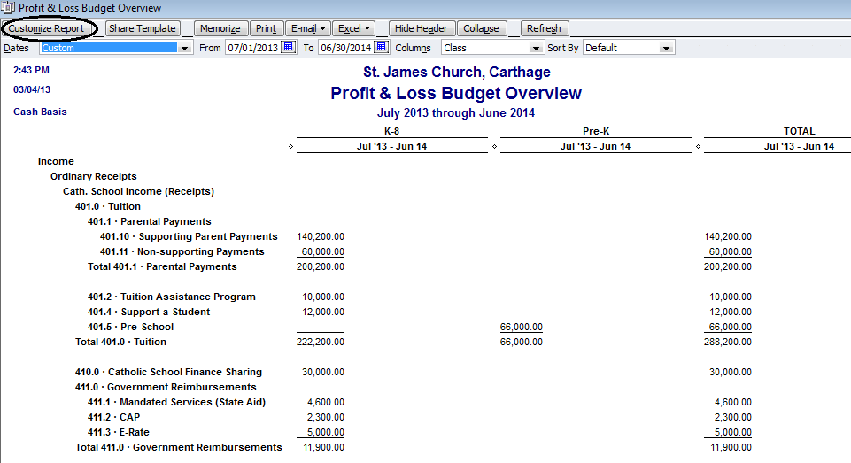

Jul 25 – June 26

Jul 25 – June 26

Jul 25 – June 26

06/30/2026

07/1/2025

July 2025 through June 2026

4/30/25

**Step 5:** QuickBooks displays the Modify Report window with the Display tab, shown in figure 6. First confirm that the Report Basis is “Cash”. Next you will need to select “Total only” in the “Display columns by” field if you don’t have a Pre-K (School Budgets by class will have “Class” in the “Display columns by” and will not need to be changed. Next select the tab “Filters” as indicated by the arrow in figure 6.

Figure 6: Modify Report window, Display tab.

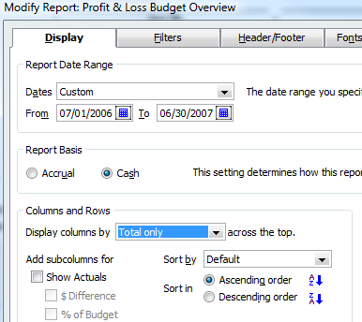

06/30/2026

07/01/2025

**Step 6:** QuickBooks displays the Modify Report window with the Filters tab, shown in figure 7. Select the drop-down box next to “All income/expense accounts”, then scroll up and select “Multiple accounts” (circled below).

Figure 7: Modify Report window, Filters tab.

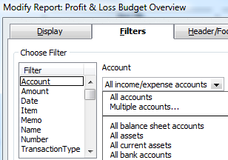

**Step 7:** QuickBooks displays the Select Account window, shown in figure 8. Next scroll down the list of accounts and start selecting accounts starting with Catholic School Income (Receipts) to account number 480.9 “Advancement Fundraising (net)” and include any subaccounts of 480.9, if necessary. For parishes with a school do not select any of the Parish Income accounts, Charitable Collection, Mass Accounts, and Cemetery income account numbers. With regards to the expenditures start by selecting account Catholic School Expenses to account number 589.0 “Other Advancement expenses” and include any subaccounts of 589.0, if any. Note: do not include expense account number 570 “School Support/Subsidy Exp.” and any subaccounts of 570, if necessary. Also, the parishes with a school do not select any of the Parish Expenses, Charitable Collection, Mass Accounts, and Cemetery expense account numbers. Once you have selected all of the school’s accounts select the Okay button.

Figure 8: Select Account window.

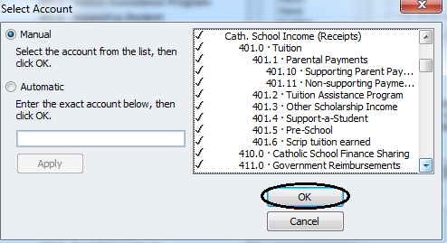

**Step 8:** Select the Header/Footer tab as shown in figure 9 below. Change the Report Title by inserting your cursor before the words Profit & Loss Budget Overview and type in the word School, which will change the Report Title to read as “School Profit & Loss Budget Overview”. Select the OK button at the bottom of this window to view the newly created report.

Observe: In figure 9, the Company name is listed as St. James Church, but the name should be changed to reflect the school name and a comma should be added then the city name, for example: “Augustinian Academy, Carthage”. This will allow anyone reviewing the report to easily identify your school report correctly.

Figure 9: Modify Report window, Header/Footer tab.

4/2025

July 2025 through June 2026

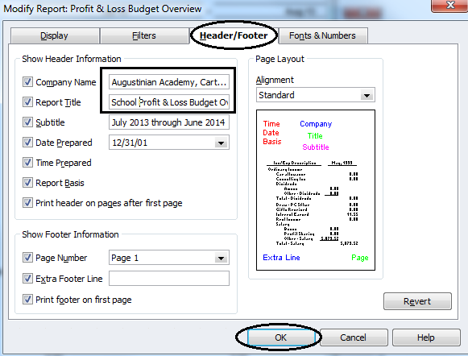

4/2017

**Step 9:** QuickBooks displays the newly created School Profit & Loss Budget Overview report, shown in figure 10 below. After reviewing this report and if everything is in order select the Memorize button (circled in figure 10). Figure 11 is the School Profit & Loss Budget Overview by class report.

Figure 10: School Profit & Loss Budget Overview report.

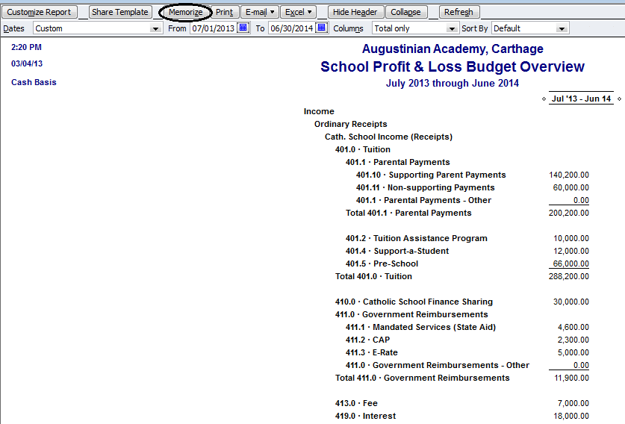

Jul 25– Jun 26

July 2025 through June 2026

06/30/2026

07/01/2025

4/30/25

Figure 11: School Profit & Loss Budget Overview report by class.

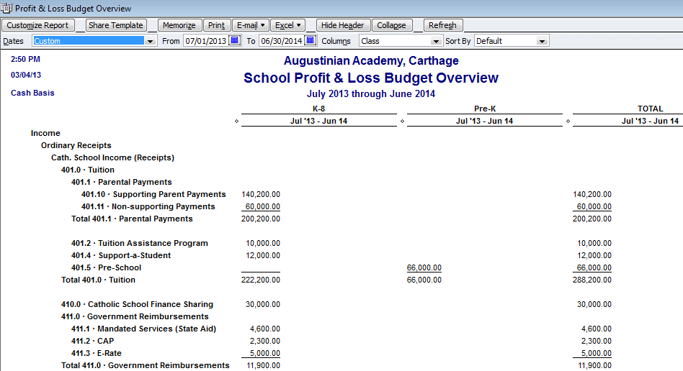

Jul 25 – Jun 26

Jul 25 – Jun 26

Jul 25 – Jun 26

July 2025 through June 2026

06/30/2026

07/01/2025

4/30/25

Observe: In figure 11, the columns can be resized by left-button-click and hold on the diamond to the right of the first column (Pre-K) and drag it to the left and note the dotted line that will appear as shown in figure 12. Figure 13 School Profit & Loss Budget Overview with columns resized.

Figure 12: School Profit & Loss Budget Overview report by class resizing.

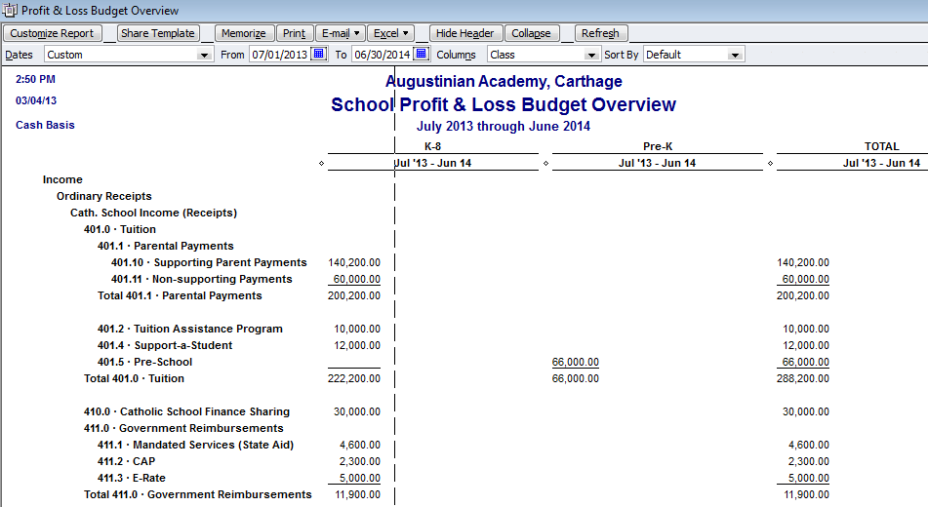

Jul 25 – Jun 26

Jul 25 – Jun 26

Jul 25 – Jun 26

July 2025 through June 2026

06/30/2026

07/01/2025

4/30/25

Figure 13: School Profit & Loss Budget Overview report by class resizing completed.

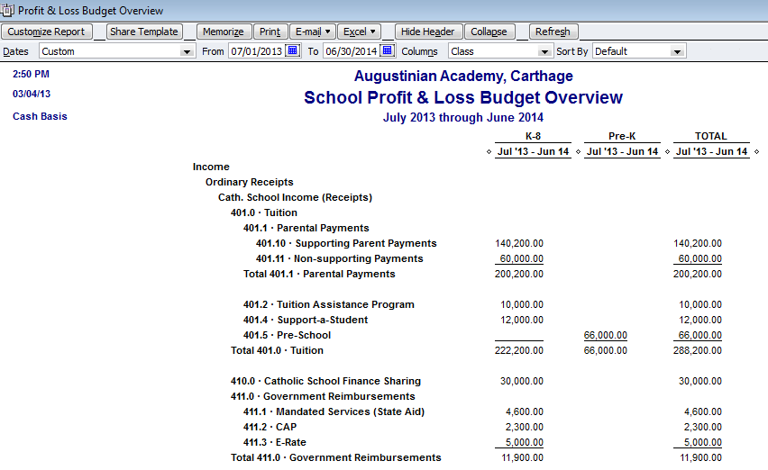

07/01/2025

06/30/2026

Jul 25 – Jun 26

Jul 25 – Jun 26

Jul 25 – Jun 26

July 2025 through June 2026

4/30/25

**Step 10:** QuickBooks displays the Memorize Report window, shown in figure 14. This window lets you permanently save this newly created report, so you won’t have to go through all the steps to modify the report in the future. If the report title appearing under “Name” is the same as you entered in step 8 above, then select the OK button.

Observe: In figure 14, you can also save reports in a memorized report group. To do this, select the box for Save in Memorized Report Group, then use the drop-down list to select the report group in which the memorized report should be saved.

Figure 14: Memorize Report window.

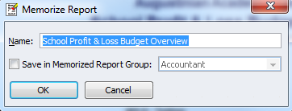

**Step 11:** After you memorize these settings in step 10, you can later produce the exact same report by choosing the memorized report from Reports, Memorized Reports, and then School Profit & Loss Budget Overview as shown in figure 15.

Figure 15:

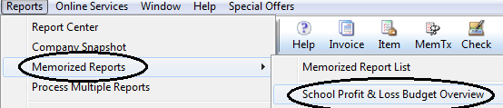

**Step 12:** Before E-mailing the School Profit & Loss Budget Overview to the diocese you may want to edit the default E-mailing text used for reports by selecting Edit from the main menu, then select from the drop-down list Preferences. From the list of icons on the left select “Send Forms” (circled below as shown in figure 16). Next select “Reports” under “Change default for” (rectangle box) to bring up the standard text used when E-mailing QuickBooks reports. Now you can change the body of the letter to include contact phone numbers/E-mail address. Also, add the principal’s name and title, shown in figure 17.

Figure 16: Edit/Preferences, Send Forms/Company Preferences window.

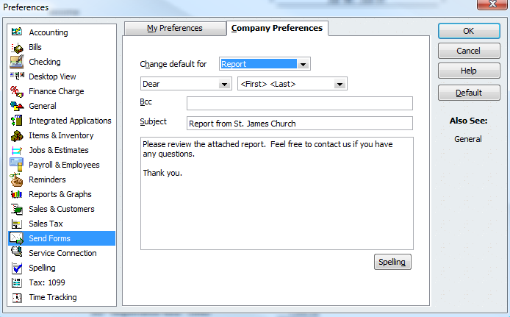

Observe: the change in text (in rectangle highlighted box) in figure 17 shown below as compared to figure 16 above. This change in text will now appear in the body of all E-mails with regards to E-mailing reports.

Figure 17: Edit/Preferences, Send Forms/Company Preferences window with edited text.

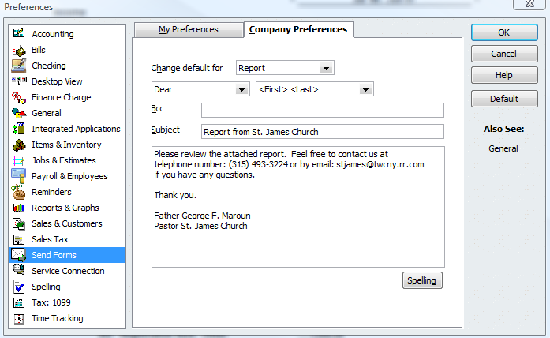

Father Todd Thibault

**Step 13:** The following steps are for E-mailing the QuickBooks School Profit & Loss Budget Overview to the diocese. Select on the E-mail button (circled below as shown in figure 18) “Send report as Excel”.

Figure 18: School Profit & Loss Budget Overview report.

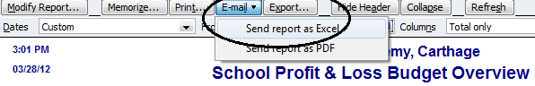

4/30/25

**Step 14:** If the E-mail Security window appears, shown in Figure 19. Select the OK button.

Figure 19: E-mail Security window.

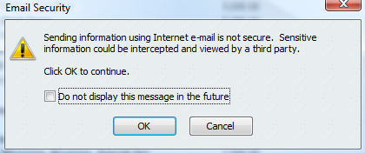

**Step 15:** In figure 20 you will need to add text in the subject line (see circled text in figure 20 below) that identifies the type of report that is being sent to the diocese. Also, you will need to type your school’s Email address in the “From” field. In the “To” field you will need to type [vlalonde@rcdony.org](mailto:vlalonde@rcdony.org) as shown. Once all text is added select the “Send Now” button shown in the highlighted rectangle below.

Figure 20: Edit E-mail Information window.

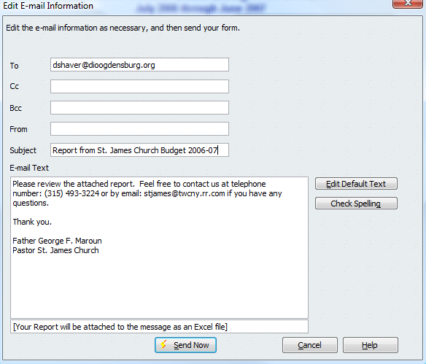

2025-26

Father Todd Thibault

vlalonde@rcdony.org

**Step 16:** A “Launch Web Browser?’ window may appear, if so, select the OK button to continue.

**Step 17:** Next a “QuickBooks E-Mailing” window may appear and select the option “Automatically connect without asking for a password”, then select the “Next” button.

**Step 18:** A “Confirm E-mail Address” window will appear next and please make sure your E-mail address is typed correctly, then select the OK button. QuickBooks should go online and send the report for you.