**How to Create a School Budget in *QuickBooks Pro***

Before you begin using QuickBooks Pro to create the *School Profit & Loss Budget Overview* report, the school must first develop the budget figures. Budgeting strategies the school could use when developing a school budget include: 1) use last year’s actual figures or last month’s actual figures as the basis for this year’s budget, or 2) examine each account and then calculate (estimate) a good figure to use for the budget amount based on an increase or decrease of percentage or a flat amount.

Example 1: if we use the first strategy we may see that our school averaged about $2,500.00 per month in account number 410 Catholic School Finance Sharing; we can then assume that we will continue to receive approximately $30,000.00 ($2,500.00 x 12 months = $30,000.00) for next fiscal year finance sharing barring any major changes.

Example 2: we should use the second strategy for items such as salaries, since the salaries may increase over last year’s amount based on a percentage, or flat amount of a raise, or even an increase in hours worked. If an hourly wage will increase by $.50 per hour and if the employee works 20 hours per week you will multiply the new hourly wage by 20 hours to come up with the new weekly gross amount of salary, then multiply this new weekly amount by 52 weeks to come up with next year’s budget amount.

Good budgeting will use both of these strategies to come up with a school budget that allows the Principal to plan the school’s finances for the year. The principal will also decide how the budget figures will be spread throughout the fiscal year, for example: the principal knows that a fund raiser is taking place in May, so he/she will put the budget figure for account 480.9 Other fundraising in the 11th month (May of the fiscal year) instead of spreading this figure over 12 months. Also, the principal may decrease the budget figures in July and August for 401 Tuition as compared to the other 10 months, since the school is on break during those months. In addition, elementary schools will separate their budgets by classes one being Pre-kindergarten and the other being Kindergarten to the highest grade level.

Once the school budget is developed on paper we can now add the new budget in QuickBooks Pro by following these steps:

**Step 1:** From the main menu select Company, and then select Planning and Budgeting from the drop-down menu and then select Set Up Budgets. QuickBooks displays either the Create New Budget window if you never created a budget in QuickBooks before, shown in Figure 1, or QuickBooks will display your current budget window shown in Figure 2. If your current budget window is displayed select the Create New Budget button (rectangle highlight in figure 2) to bring up the Create New Budget window.

**Step 2:** From the Create New Budget window select the fiscal year period. You can change the fiscal year by selecting the up or down boxes. Make sure that the button for Profit and Loss is selected, as shown in Figure 1. Note: there is no need to create a budget for the Balance Sheet accounts. Next select the Next button.

Figure 1: Create New Budget window.

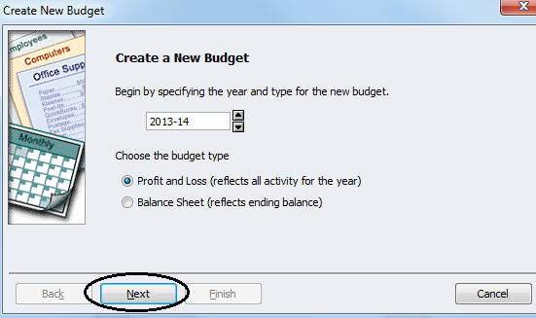

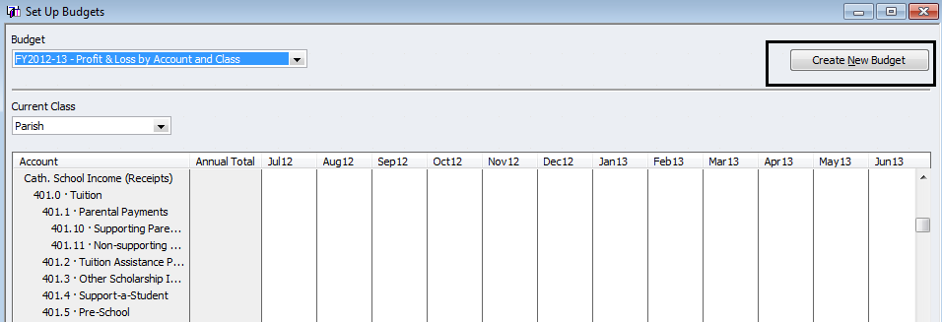

2025-26

Figure 2: Your current budget window.

FY2025-26 Profit & Loss by Account and Class

Jul 25 Aug 25 Sep 25 Oct 25 Nov 25 Dec 25 Jan 26 Feb 26 Mar 26 Apr 26 May 26 Jun 26

**Step 3:** For most of the school budgets there will be additional criteria button Class selected. For those schools without a Pre-kindergarten class, then No Additional Criteria would be selected. Select the Next button, as shown in Figure 3.

Figure 3: Create New Budget window, Additional Criteria Class.

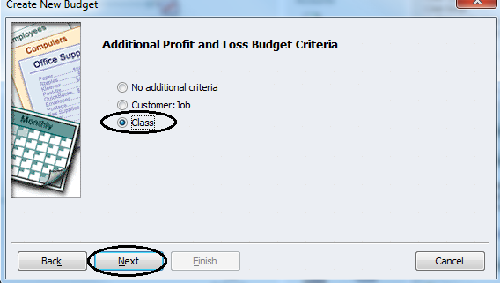

**Step 4:** Select whether to create a budget from scratch or from previous year’s actual data. Next select the Finish button. In our example we will select from scratch, as shown in Figure 4.

Figure 4: Create New Budget window, “from scratch” or using last year’s actual amounts.

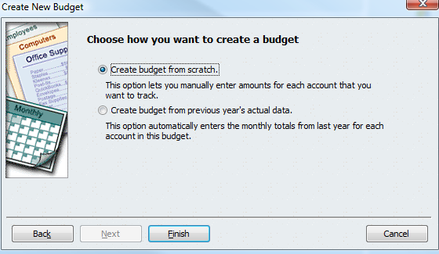

**Step 5:** QuickBooks displays the Set Up Budgets window, partially shown in Figure 5. This window is used to record the amount that you expect for each revenue and expense account for each month during the fiscal year in which you are budgeting. Note: that the first Class selected is K-8, so only the revenue and expenses for the Kindergarten to 8th grade will be input, and then the class will be changed to Pre-K for input of their budget.

Figure 5: Set Up Budgets window.

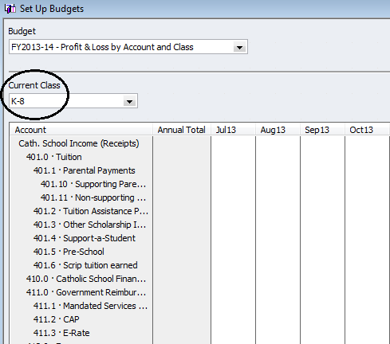

FY2025-26 – Profit & Loss by Account and Class

Jul 25 Aug 25 Sep 25 Oct 25

**Step 6:** Select an account (401.10 Supporting Parent Payments) and then type the amount that you would like to have budgeted for the month, shown in Figure 6.

Figure 6: Set Up Budgets window, selecting an account and recording first month’s amount.

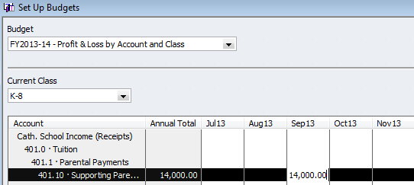

140,000.00

FY2025-26 – Profit & Loss by Account and Class

Jul 25 Aug 25 Sep 25 Oct 25 Nov 25

Jul 14 Aug 14 Sep 1

Jul 14 Aug 14 Sep 14 Oct 14 Nov 14

**Step 7:** Select the Copy Across button at the bottom left-hand side (not shown) to copy the budgeted amount from this month into the rest of the fiscal year’s succeeding months, shown in Figure 7. Note: not all twelve months shown in Figure 7 due to size of image.

Figure 7: Set Up Budgets window, using Copy Across button.

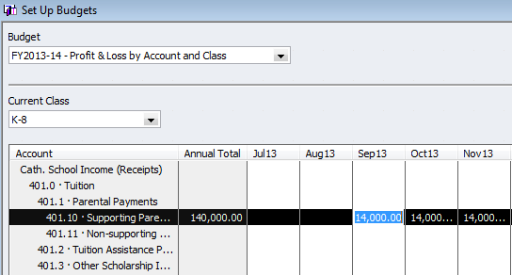

FY2025-26 – Profit & Loss by Account and Class

Jul 25 Aug 25 Sep 25 Oct 25 Nov 25

**Step 8:** You can now select a certain month to increase or decrease by simply changing the amount due to an expected change for that month. Note: this change increases or decreases the annual total, shown in Figure 8.

Figure 8: Set Up Budgets window, adjusting an amount for one month (September increased by $200.00).

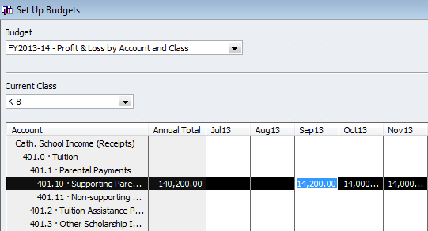

Jul 25 Aug 25 Sep 25 Oct 25 Nov 25

FY2025-26 – Profit & Loss by Account and Class

**Step 9 (Optional):** After recording the amounts for your budget if the annual total is not what the Principal wants it to be, or you brought in the previous year’s amounts and you need to adjust the amounts, select the Adjust Row Amounts button at the bottom left-hand corner (not shown). QuickBooks displays Adjust Row Amounts window, shown in Figure 9. Select either the *1st month* or *currently select month* to increase or decrease by a percentage or an amount.

Figure 9: Adjust Row Amounts window.

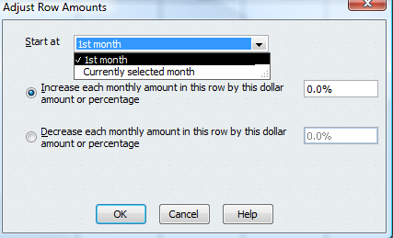

**Step 10:** Repeat steps 6 to 8 (step 9 optional) for each revenue and expense account for which you want to have a budgeted amount. Select the Save button when finished.

Once you have recorded your school budget in QuickBooks Pro, you can send this budget in excel format by email to the Diocese of Ogdensburg; please review instructions for *“School Profit & Loss Budget Overview 2025-2026”.* Note: that you can compare your actual amounts with the budgeted amounts by selecting from the main menu Reports, and then selecting Budget vs. Actual. QuickBooks displays the report and you can adjust the dates to have the period you want to compare. This Budget vs. Actual report should be printed in landscape, since it includes both percentage and amount differences. The report could be adjusted to remove one of two (percent or amount) columns if not needed. **This Budget vs. Actual report is a good management tool to be used by the Principal and the school board members for managing the school finances**.

If you have any questions with regard to QuickBooks Pro software please feel free to contact:

Amanda Frary at the Diocese of Ogdensburg (315) 605-1090 or Email at: afrary@rcdony.org.